Unity College 2022 Internship Opportunities:

Four new ones at the top of this list:

- Travis Hamilton at Arbortech.org (207) 691-2873
Arbortech.midcoadt@gmail.com
Arborculture position needing own transportation to Belfast:
A tree company near Belfast, Maine performing ground duties such as tree identification, pruning, preservation and bucket duties and climbing as well.
Will assist the employee to get arborist license.
Daily duties begin at the office of the owner and employee turns out from there.
Safety mindedness imperative.
Will work with the student and me to turn this position into a seasonal, full-time, and/or internship position.
Free firewood available.

- Laurie Rose Day (207) 931-7710
Seven Lakes Alliance / Youth Conservation Corps
7lakesalliance.org laura.roseday@7lakesalliance.org
in the Belgrade Lakes, Maine
There is a link to their application at this website.
Pay is $13.50/hour but need own transportation.
Will work with student and me to turn either of the positions offered into an internship.
a) Environmental Engineering and Landscaping
Erosion Control of the lake shores.
Effort is to keep erosion out of the lakes, primarily soil that contains phosphorus and phosphorus pollution remediation.
b) Courtesy Boat Inspector (a summer position):
Duties include:
Work with the public to have them voluntarily allow you to inspect their boats for plant material, therefore people skills necessary to work with the public.
The goal is to keep invasive species out of the lakes.
Data entry of results and findings.
Knowledge of plant species necessary. Alliance will train.

- Wilderness Lodge / Camp Angel Hibbs (207) 731-7755
Duties include lawn mowing and other maintenance functions.
Position provides room, board, and pay.
Will work with student and me to turn the position into an internship by which the students will learn about the wildlife and flora or the area, as well as skills necessary to run a wilderness camp/lodge.

- Title: MGS Coastal Marine Geology Intern:
https://www.maine.gov/dacf/mgs/mgs_coastal_intern_2022.pdf
Person to contact:
Amber T H Whittaker
Senior Geologist
Maine Geological Survey
Maine Department of Agriculture, Conservation and Forestry
207-287-2803 | Amber.H.Whittaker@maine.gov
www.maine.gov/dacf/mgs/

- Title: Grassy Waters Preserve’s Environmental Education Summer Internship Program.
This is a paid 10-week college internship program in the Everglades. Learn more information about the canoeing, dipnetting and other hands-on environmental education activities that you will assist with at: https://www.wpb.org/government/public-utilities/grassy-waters-preserve/school-programs
Duration of Internship: May 31 – August 5, 2022
Application deadline – April 4, 2022
Person to contact: Charles Wilson at cwilson@wpb.org
Environmental Education Coordinator
Grassy Waters Preserve
Email: cwilson@wpb.org
Office Phone: 561-804-4985
Or, watch the video about the grant/internship: https://www.youtube.com/watch?v=fRdzLN3sXQ4&list=PLBStMaSddHhzhGw0K4z95KedAKAy6y4gZ

- Title: The Farm @ VYCC is hiring for several AmeriCorps positions! These are more permanent than internship.
The Vermont Youth Conservation Corps’ Food and Farm Program is a dynamic youth development, diversified agriculture and food security initiative. We believe in the power that food has to connect us to the land, our community, and each other. We engage young people in organic farming and culinary education on our historic 400-acre campus in Richmond, Vermont where we grow organically certified vegetables and pasture- raised chickens that are distributed to more than 400 families through our nationally recognized Health Care Share project.
They will be hiring 7 Project Leads:
Project Leads play a leadership role in one of the following areas of our Program – Production, Post-Harvest and Sales, Food and Nourishment, the Health Care Share and Community Engagement. They serve on the farm from freezing March mornings, through sweaty July days, until crisp October evenings. They serve out in the fields, in the wash station, in the kitchen, work with volunteers and Health Care Share members and jump in to problem solve the daily challenges of the Food and Farm Program. Project Leads bring their adaptability, commitment, and passion for food & farming to the team. Details on each specific role in the link below.
They also will be hiring: Farm Crew Leaders.
The responsibilities shift across the season. Spring is for learning and doing: tending crops in greenhouses and planting the fields; working with volunteers. In summer, they lead either a youth or young adult crew. In fall, they harvest mountains of vegetables in support of Health Care Share project.
There are two types of Crew Leader positions- leading a crew of youth or young adults. Regardless of age, crews work in all areas of the farm; they plant and harvest, care for livestock, and explore how to cook with what they’ve grown.
To learn more and apply: https://www.vycc.org/apply/lead/
Person to contasct:
Justina Soltys (former Unity student)
Pronouns: She/her
Farm Production Coordinator
Vermont Youth Conservation Corps 802.434.3969 ext. 211

- Great Pond Outdoor Adventure Center
Great Pond is a military campground located about 1 hour from Unity in a town called Great Pond ME. We offer outdoor recreation to active duty and retired military. Our position is a paid and offers free housing.

Person to Contact: Judy Manzo @ greatpondoac@rivah.net

5) Wild Care Cape Cod is offering internships:
Subject: Internship Program Internship <internship@wildcarecapecod.org>
Contact person below for details:
Person to contact: Jennifer Taylor
Animal Care Coordinator
Internship Coordinator
Wild Care, Inc
10 Smith Lane
Eastham, MA 02642
508-240-2255
http://www.wildcarecapecod.org/

- Coastal Mountains Land Trust is hiring two summer interns who will work on maintaining and improving Land Trust preserves, trails, and conservation easements, in Knox and Waldo Counties. Much of the work will occur outdoors, though the position also includes work at the Land Trust's Office in Camden. The interns will gain hands-on experience in conservation management, trail maintenance, land stewardship, and volunteer engagement, and will develop a working knowledge of how land trust organizations function. These are 8-week internships with flexible start dates in June. $15/hour and work-related travel reimbursed. Visit https://www.coastalmountains.org/employment to learn more and apply.
Deadline to apply is March 1st.
Person to contact: Jack Shaida, Stewardship and Lands Project Manager
Coastal Mountains Land Trust
101 Mount Battie St, Camden, ME 04843
(207) 236-7091
jacks@coastalmountains.org
www.coastalmountains.org

7)
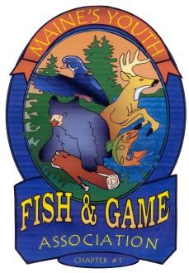
Maine Youth Fish and Game Association
Po Box 337
Stillwater, ME 04489

Maine Youth Fish and Game Association (MYFGA) is accepting applications for the position of Summer Camp Director.
Duties of the Summer Camp Director include:
- Hiring a support staff of counselors and an Assistant Director
- Planning camp activities and presentations
- Financially planning all aspects of Summer Camp
- Work with members of MYFGA board of directors
- Represent MYFGA at local sportsman shows
- Manage a team of six staff members
Required Qualifications:
- At least 21 years of age
- First aid and CPR certified
- Pass a criminal background check
- Previous experience in child management (teacher, counselor, etc)
- Possess a valid driver’s license
MYFGA Summer Camp is held on location at Pickerel Pond in TWP 32, just outside of Milford, Maine. Camp is offered over four weeks, starting the last week of June and continuing through July (week of July 4th is off). Camp is divided into two age groups, 8-11 and 12-15. The younger group is a day camp running 8-5 Monday through Friday. The older group is a day camp with one overnight, usually occurring the last night of the week. Typical camp activities include archery, rifle shooting, canoe/kayak safety and use, fishing, wilderness survival, ATV safety, hunters safety and outdoor cooking, to name a few.
Pay is based on experience and longevity. All interested parties should send a cover letter and resume to the address listed above.
Person to Contact: matt.redding@maineyouthfishandgame.org or by calling Matt at 207.852.0528
8)

Position | Teen Text Line Peer Support Specialist
Reports to | Teen Text Line Program Manager / Teen Text Line Clinical Supervisor
Salary/Rate | $12/hour (5-20 hours a week)
Benefits | This position is per diem and does not receive benefits

Summary of Job Position:
The NAMI Maine Teen Text Line supports youth living with mental health challenges (ages 13 – 24) across the state. It provides support based on a model of peer support. It does not operate as a crisis line/resource. The Teen Text Line Peer Support Specialist provides peer support to young people utilizing the line. The Support Specialist will engage in positive text exchanges by utilizing destigmatizing language, by emphasizing Unit personal empowerment, and by connecting youth to the natural/community mental health supports in their lives.

Essential Functions and Responsibilities
- Learn and utilize Avachato, the web/phone- based texting platform utilized by the program.
- Learn and utilize all state/NAMI mandated data reporting systems (Apricot Connect).
- Provide Peer Support to other young people across the state. This will include providing:
  - reassurance through validation and non-judgmental support.
  - access to self-help strategies, coping skills, and vetted phone apps.
  - referral to professional services and assistance in locating local therapists, counselors, etc.
- Complete all required trainings by the funding source (state of Maine) and agency (NAMI).
- Appropriately seek out and utilize supervision and support while providing peer support.
- Attend weekly staff meetings/clinical supervision sessions.
Qualifications
- Due to contractual requirements, employee must be between age 18-24.
- Demonstrated ability to effectively work implement outlined contract deliverables as evidenced by previous employment.
- Have flexible schedule to accommodate shifts (TTL operates daily 12-10PM. Shifts are 12-5PM or 5-10PM).
- Identification as a person living with mental health and/or substance use challenges, experiencing sustained recovery, well-being, and a clear commitment to self-care.
- Successfully complete certification in Mental Health First Aid or Youth Mental Health First Aid.
- Successfully participate in and pass role play scenarios with Program Clinical Director/Manager.
- Demonstrates strengths-based approach to problem-solving,
- Demonstrates non-stigmatizing and resilience/recovery-based attitude towards mental health challenges.
- Proficient in utilizing text platforms and technological components.
- Have access to quality Wifi/Cellular Data.

Physical Effort/ Environment
Completion of the work is done offsite from the office building. Computer usage or cellular phone usage involving repetitive hand/wrist motion is also necessary.

NAMI Maine provides equal employment opportunities (EEO) to all employees and applicants for employment without regard to race, color, religion, sex, national origin, age, disability or genetics. In addition to federal law requirements, NAMI Maine complied with applicable state and local laws governing nondiscrimination in employment in every location in which the company has facilities. This policy applies to all terms and conditions of employment, including recruiting, hiring, placement, promotion, termination, layoff, recall, transfer, leaves of absence, compensation and training. NAMI Maine expressly prohibits any form of workplace harassment based on race, color, religion, gender, sexual orientation, gender identity or expression, national origin, age, genetic information, disability, or veteran status. Improper interference with the ability of NAMI Maine’s employees to perform their job duties may result in discipline up to and including discharge.

9) I'm excited to share that we have openings for paid internships at Camp Nashoba this summer.
We would love to chat further regarding open positions and how we can continue working with Unity students to have an incredible summer together. Unity Students that we have worked with in the past focused in Adventure Education and Conservational Law.
We are looking for a Naturalist that can develop and cultivate an outdoor leadership program at Nashoba. We recently acquired some new land adjacent to our original property and are hoping to establish that program there.
Positions that may be fitting for Unity Students:
Culinary Nursing Climbing Instructor Trips Leader(21+)
as well as many others that are listed on our website:
https://www.campnashoba.com/staff/working-at-cnn/
Person to contact: Kat Lemieux (She/Her) Associate Director
+1 978 486 8236 (Winter Office) "Fresh Air & FUN!" visit us at CampNashoba.com
10) Central Aroostook Soil and Water Conservation District in Presque Isle, Maine has two openings for INTERNS to assist with our soil health and wildlife habitat conservation efforts. CASWCD has been active in Presque Isle since 1947 and is a partner with the Natural Resources Conservation Service, NRCS, by providing technical assistance to that agency. CASWCD Serves as the link between the landowners and NRCS.

Interns will answer to Project Director/Executive Director and will be expected to possess excellent written and verbal communication skills. Successful candidates will assist the Project Director in all aspects of planting, maintenance, harvesting and data collection of research trials. Candidates will be required to prepare and present one seminar during a field day that covers the work that they did. Successful candidates must have their own transportation and be able to lift 50 pounds.
This internship will last for one year after the initial hiring date. Pay will depend upon experience.
Interested parties should send a cover letter and resume to Randy Martin, Executive Director, Central Aroostook Soil and Water Conservation District 735 Main Street Suite 3 Presque Isle, Maine 04769

11) Technician Position

Central Aroostook Soil and Water Conservation District in Presque Isle, Maine has two openings for TECHNICIANS to assist with our soil health and wildlife habitat conservation efforts. CASWCD has been active in Presque Isle since 1947 and is a partner with the Natural Resources Conservation Service, NRCS, by providing technical assistance to that agency. CASWCD Serves as the link between the landowners and NRCS.

Technicians will answer to Project Director/Executive Director and will be expected to possess excellent written and verbal communication skills. Successful candidates will assist the Project Director in all aspects of planting, maintenance, harvesting and data collection of research trials. Successful candidates must have their own transportation and be able to lift 50 pounds.

This position will last for up to one year after the initial hiring date, but can be flexible for school schedules. Pay will depend upon experience.

Interested parties should send a cover letter and resume to Randy Martin, Executive Director, Central Aroostook Soil and Water Conservation District 735 Main Street Suite 3 Presque Isle, Maine 04769, or at the email on this letterhead.

12) Subject: Maine Geological Survey intern position

Hello all,
MGS has just posted another intern position to help with our Data Preservation project. This is an office-based position, but the intern will have the opportunity to join us a few times in the field, if interested. The position is cataloging, scanning, and georeferencing air photos.

https://www.maine.gov/dacf/mgs/mgs_data_pres_intern_2022.pdf
Contact person:
Amber T H Whittaker
Senior Geologist
Maine Geological Survey
Maine Department of Agriculture, Conservation and Forestry
207-287-2803 | Amber.H.Whittaker@maine.gov
www.maine.gov/dacf/mgs/

13) 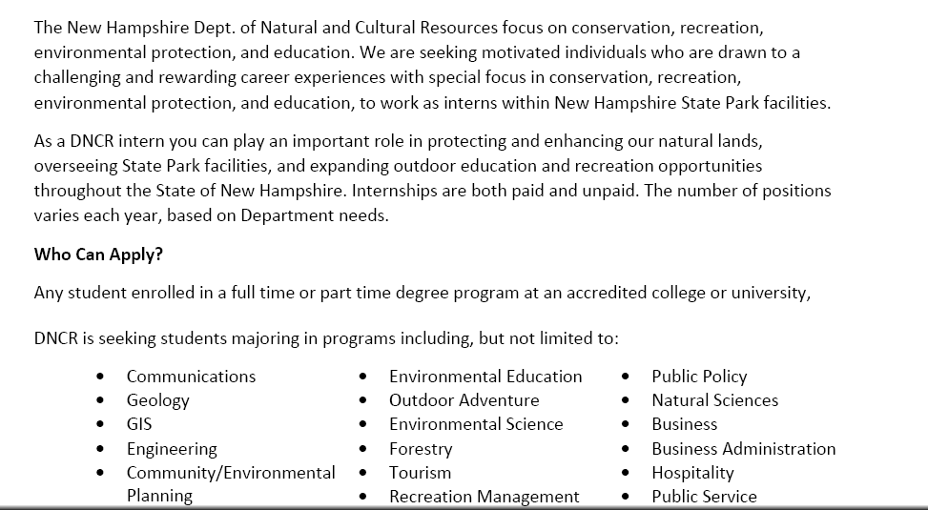
Essential Functions:
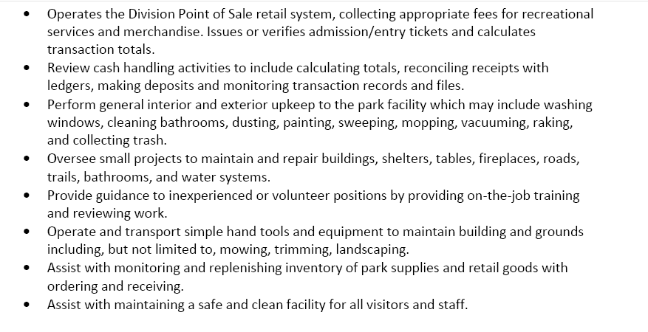
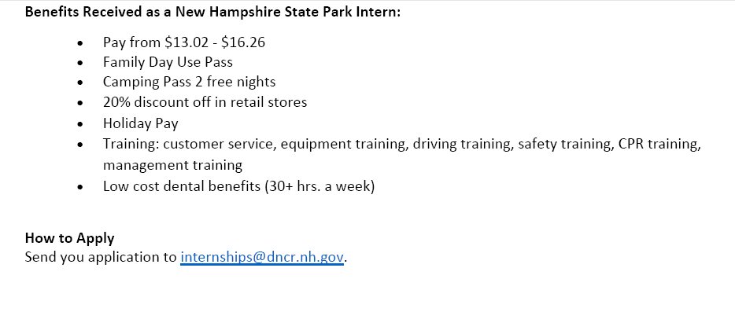
13) My name is Luke Bartol and I am the Maine State Fellow with Citizens’ Climate Lobby(CCL). CCL is a national nonprofit organization that builds grassroots support for climate legislation.
We are currently recruiting students and recent graduates to join our team as interns or fellows. We have opportunities with a variety of different departments that may appeal to students across many disciplines. These experiences provide valuable work experience, networking opportunities, and may include academic or financial benefits. You can learn more about our current openings on our website. The application deadline is March 31st, 2022.
For students looking to deepen their learning outside of the classroom, we offer a free Climate Advocacy Certificate Program each semester. This provides valuable transferable skills in advocacy, climate science, and communication over the course of a 15-week remote course. Students interested in enrolling in next semester’s program should sign up by June 1st, 2022.

CCL is a growing organization and often has open positions that we advertise here. We also post climate related jobs from other organizations in our jobs forum.
Please feel free to reach out to me at luke.bartol@citizensclimatelobby.org with any questions or to get more information!

14 ) Coastal Rivers Conservation Trust, Damariscotta, Summer Stewardship and Facilities Internship
Position Description Posted April 12, 2022
Introduction:, serving the area in and around Maine, is accepting applications for the 2022 Stewardship and Facilities Internship.
Coastal Rivers is a non-profit, membership-supported, and nationally accredited land trust and
conservation organization caring for the lands and waters of the Damariscotta-Pemaquid
Region by conserving special places, protecting water quality, creating trails and public access,
and deepening connections to nature. Since 1966, we have conserved more than 5000 acres of
land, including 71 properties and 60 privately owned conservation easements, and also
maintain over 51 miles of trails on our preserves for the public.
General Description: The Stewardship and Facilities Internship is an 8-13-week position focused
on maintaining and improving Coastal Rivers preserves, trails, conservation easements, and
facilities. Much of the work will occur outdoors, though the job also includes office tasks. The
role will involve walking over rough terrain and using hand and power tools.
The intern will gain hands-on experience in conservation management, trail maintenance, land
stewardship, facilities maintenance, and volunteer engagement and will develop a working
knowledge of how a land trust organization functions.

Preferred Qualifications:
• Familiarity with the use of power tools, such as lawnmowers, weed whackers, power
drills, carpentry tools, chainsaws, and tractors.
Position Specifics:
• Location: The position is based out of Coastal Rivers Conservation Trust’s office in
Damariscotta, Maine, but focused on conservation lands throughout our service area,
with 50-75% of time spent in the field;
• Timeframe: Approx. 24-35 hours per week over 8-13 weeks, with flexible start and end
dates between May 2 and August 28;
• Compensation: $15 to $17 per hour, depending on experience. Work-related travel is
reimbursed monthly at the prevailing federal rate (currently, 58.5 cents/mile at the time
of writing);
• Free internship housing is provided;
• COVID 19 will likely impact this position. Coastal Rivers strictly follows all state
guidelines and regularly develops policies to mitigate risk. This intern must follow all
guidelines and organizational policies while working for Coastal Rivers.

To Apply
Please email: jgrenier@coastalrivers.org with the subject Application”
Please attach your resume as a single PDF, including two to three references and a cover letter explaining your interest in this position.
15)

Coastal Rivers Conservation Trust (coastalrivers.org)
The mission of Coastal Rivers Conservation Trust is to care for the lands and waters of the Damariscotta- Pemaquid Region by conserving special places, protecting water quality, creating trails and public access, and deepening connections to nature.

Schedule:
Starts anytime May 1 to June 1 – Ends August 15 or could continue to the end of August Wed – Friday
- 9:00 am to 10:00 pm provide Courtesy Boat Inspections, Biscay and/or Pemaquid Beaches
- 10:00 – 12:30 pm Special projects to be determined
- 1:00 pm to 5:00 pm at Beachcombers’ Rest Nature Center (Pemaquid Beach) providing developing quality displays, in-person interpretation and programming.
Saturday and Sunday:
- 8:00 am to 12:00 noon provide Courtesy Boat Inspections, Pemaquid Lake
- 1:00 pm to 5:00 pm Beachcombers’ Rest Nature Center, interpretation and programs Monday and Tuesday – off
- Compensation:
- • Housing provided (a house shared with other interns).
- • Pay: $17/hr
- • Reliable personal transportation will be essential – fuel cost will be reimbursed.
- • Coastal Rivers’ shirt/name tag/hat will be provided.
Application Process:
Please submit a letter of interest. At least three references will be required. There will be an on-line
interview.
Contact Information:
Sarah Gladu
Director of Education and Citizen Science
Coastal Rivers Conservation Trust
www.coastalrivers.org
PO Box 333
Damariscotta, Maine 04543
207-563-1393 x340
- sgladu@coastalrivers.org

