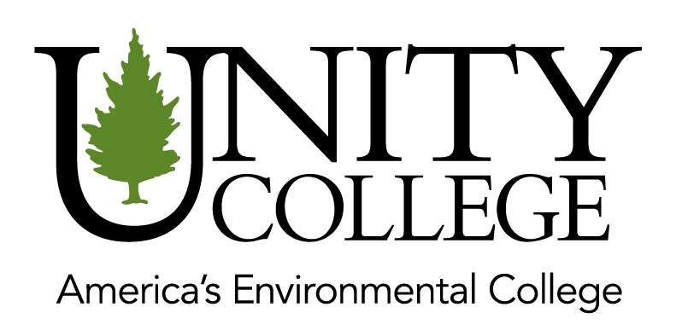
Date: [CURRENT DATE]
Contact:
[SENDER’S NAME]
[SENDER’S PHONE NUMBER]
[SENDER’S EMAIL ADDRESS]
[TOWN/CITY] Resident Graduates from Unity College
Unity, ME— [STUDENT FIRST NAME STUDENT LAST NAME] of [TOWN/CITY] graduated with a [DEGREE] [LATIN HONOR IF APPLICABLE, EG, CUM LAUDE] from Unity College on (DATE HERE). [STUDENT LAST NAME] graduated with a major in [NAME OF MAJOR(S)]. [HE/SHE/THEY] also was active in [CLUBS, STUDENT GROUPS .. ETC] at Unity College.
**OPTIONAL INFORMATION TO INCLUDE**
[STUDENT LAST NAME] will be starting a position with [NAME OF COMPANY] in [TOWN/CITY], [STATE] OR will be pursuing a [DEGREE] at [NAME OF COLLEGE/UNIVERSITY] this fall. [STUDENT LAST NAME] is the [SON/DAUGHTER] of [PARENT(S) NAME(S)] and a [YEAR OF GRADUATION] graduate of [NAME OF HIGH SCHOOL].
About Unity College
The first institution of higher education in the nation to divest from fossil fuel investments, Unity College is changing the face of higher education. The College strives to offer an accessible, affordable, and flexible education for all learners seeking a degree rooted in sustainability science, no matter where they are. For more information, visit unity.edu.
Contact: Director of Media Relations, Joseph Hegarty (207) 509-7292.

